Azure DevOps

Use end-to-end solutions on Azure to implement DevOps practices throughout application planning, development, delivery, and operations. Apply the right combination of DevOps technologies, culture, and processes to enable continual software delivery and better value for customers.

https://azure.microsoft.com/en-in/products/devops#features

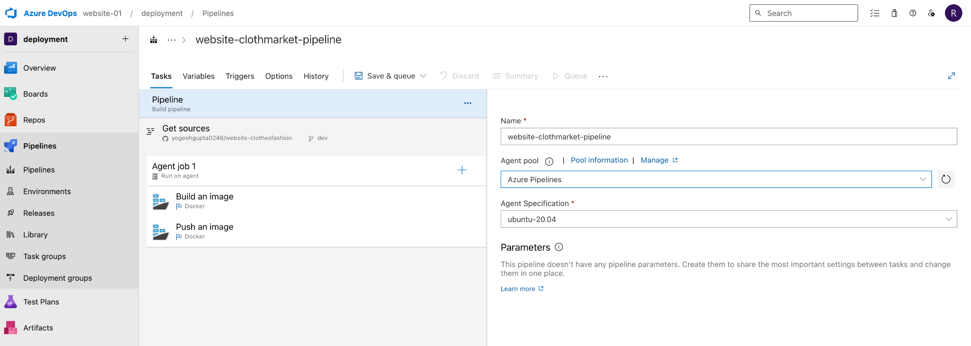https://learn.microsoft.com/en-us/azure/devops/?view=azure-devops

- Need a K8s cluster to use Azure DevOps (AKS)
- GitHub repo → To keep the dev code (website)
- GitHub repo → To keep K8s .yaml file
- Azure DevOps → Account

- How to Create Azure DevOps Account.
- go on http://dev.azure.com/
- click on Start free
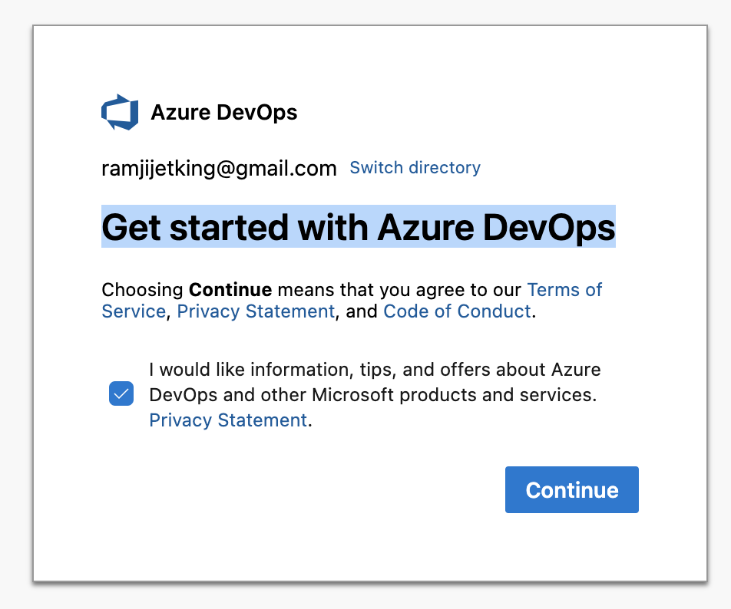
- Now create an Organization → give a name and that will become URL
- Create a Project inside the organization
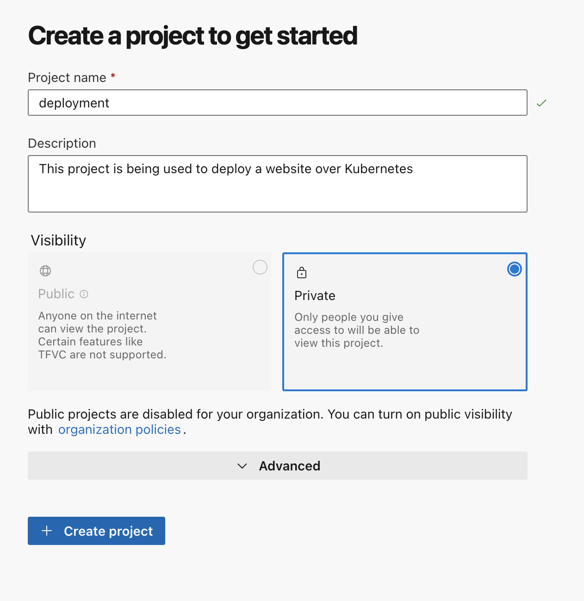
- Go inside the newly created Project → click on Pipelines → Create Pipeline → Where is Your code? → click on Use the classic editor → select Github → give Connection name → now provide the Github access detail to make a connection with Github → select Github repo → select the branch → Continue
- Now we need to select a base platform to build image and to push it on container registry → select Docker Container
- Now we are creating the below pipeline to create a docker image and push it to ACR

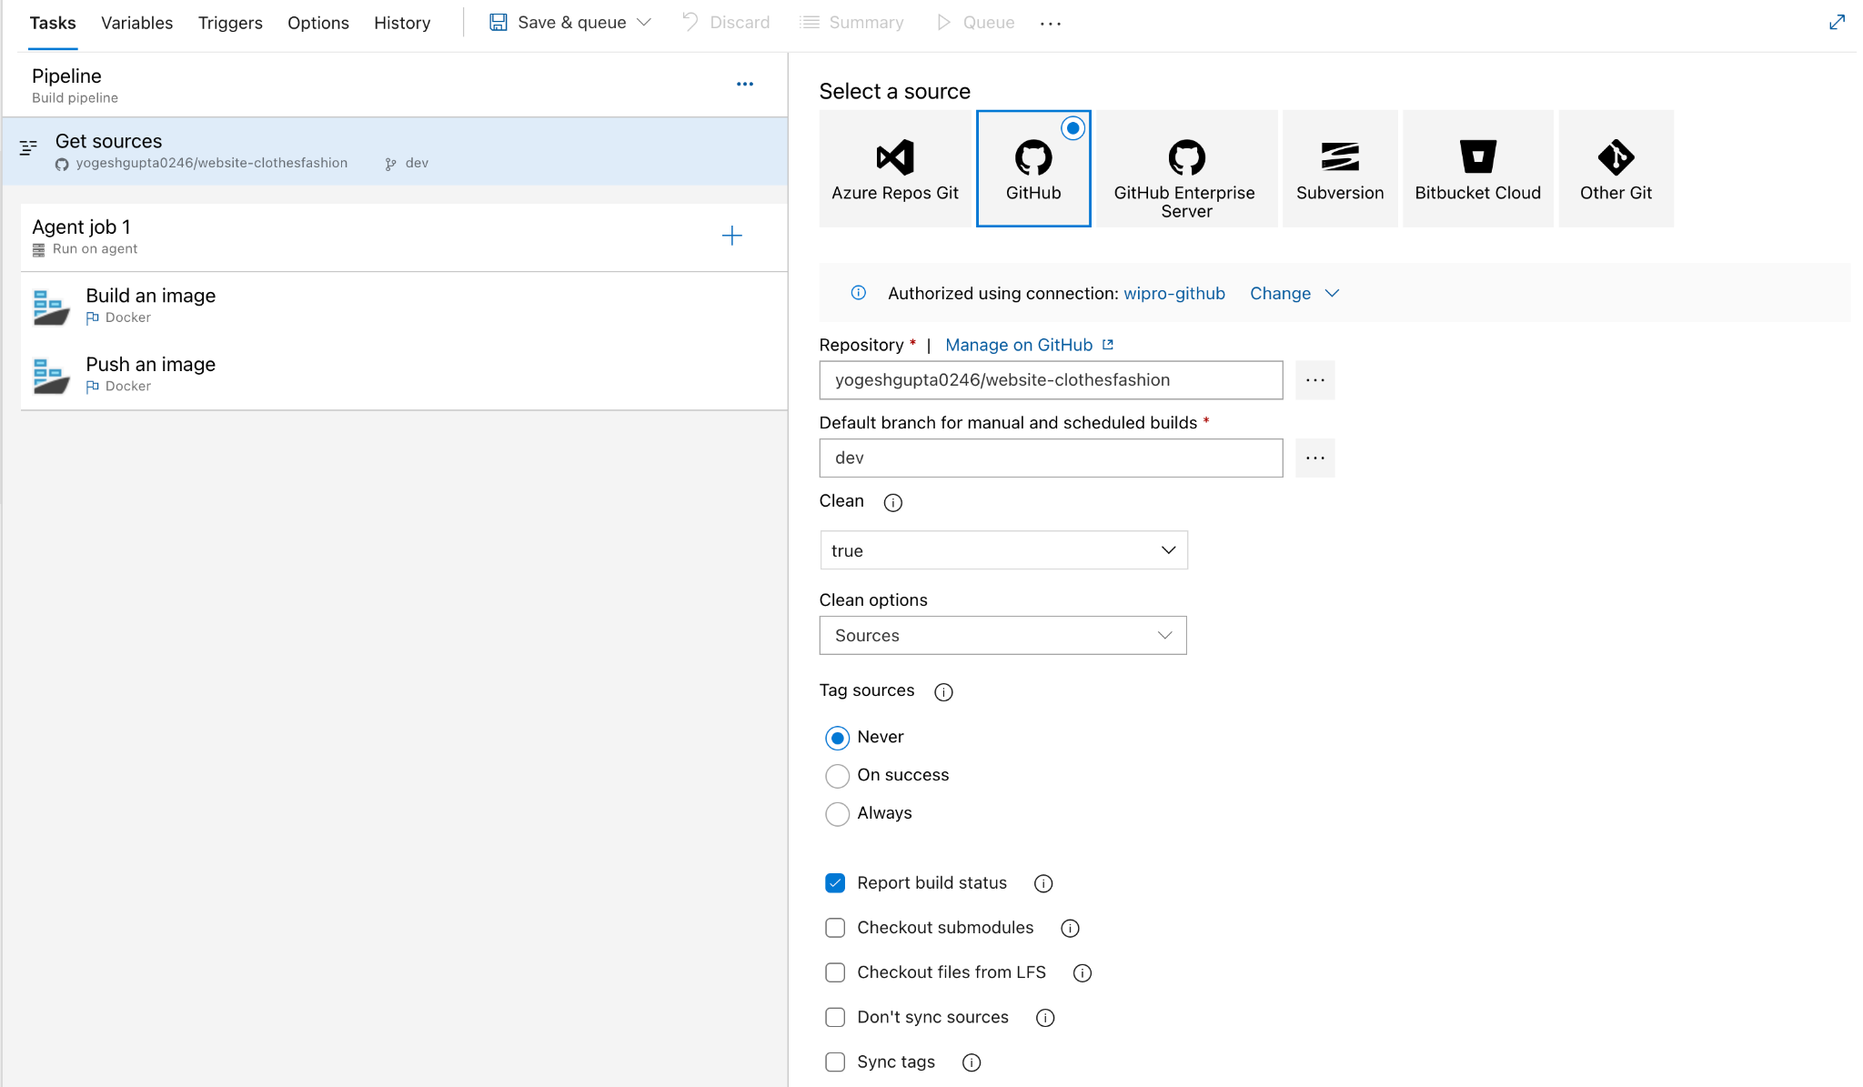

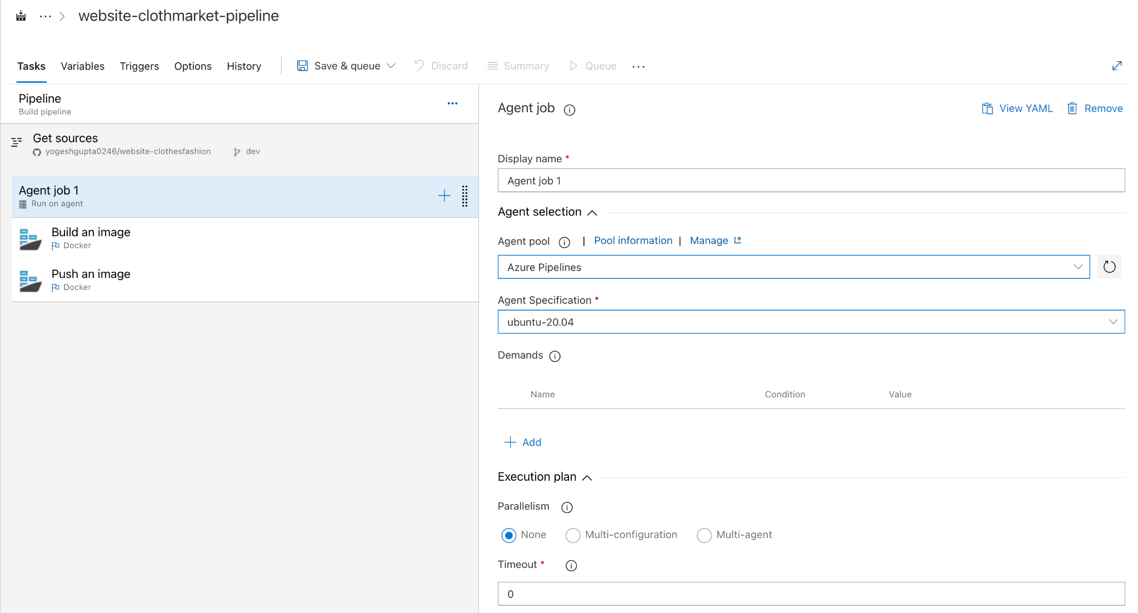

Cluster → Node Pool → Node → Pod → Container

Micro-service

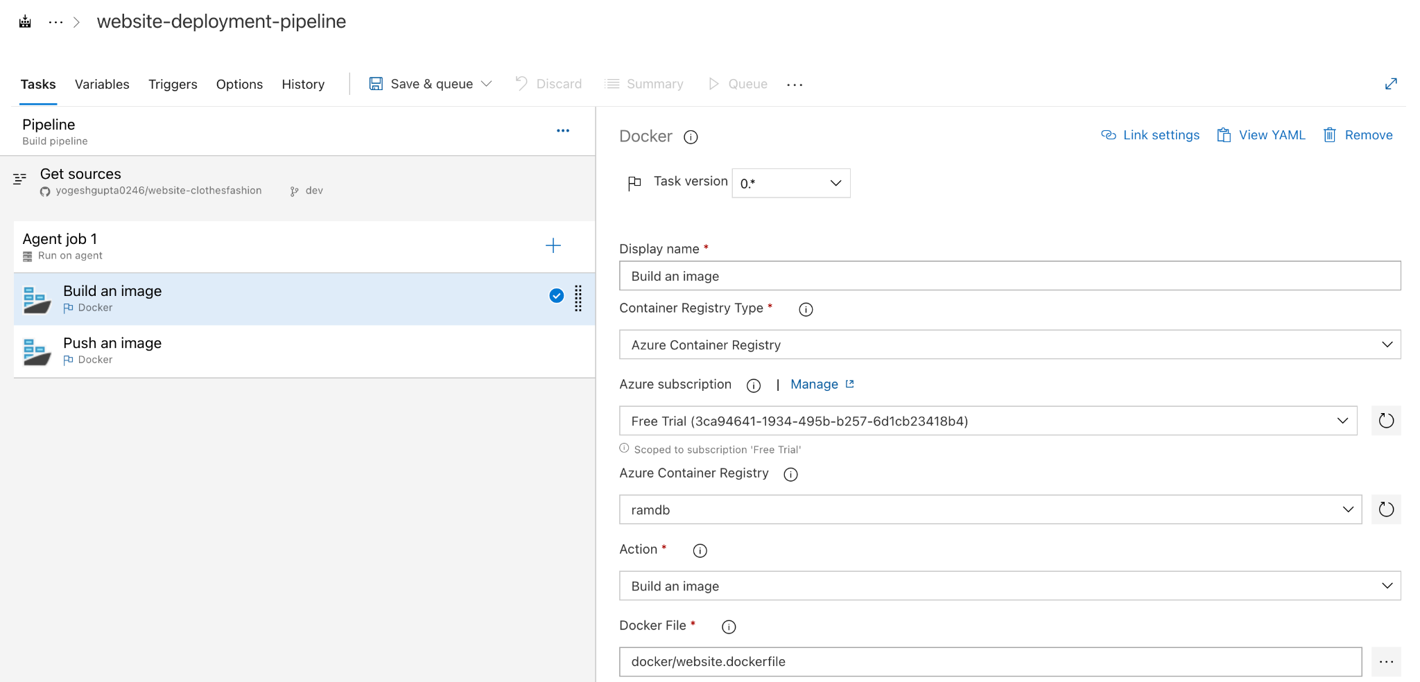

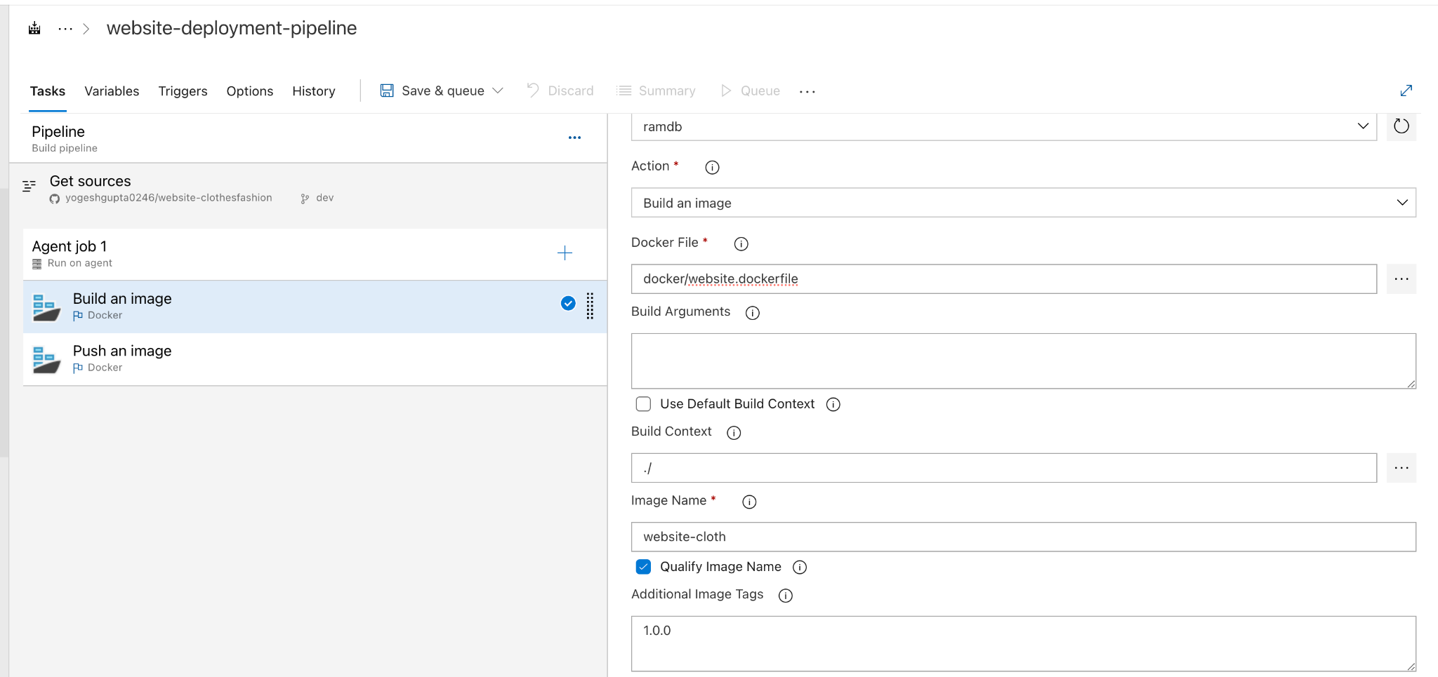

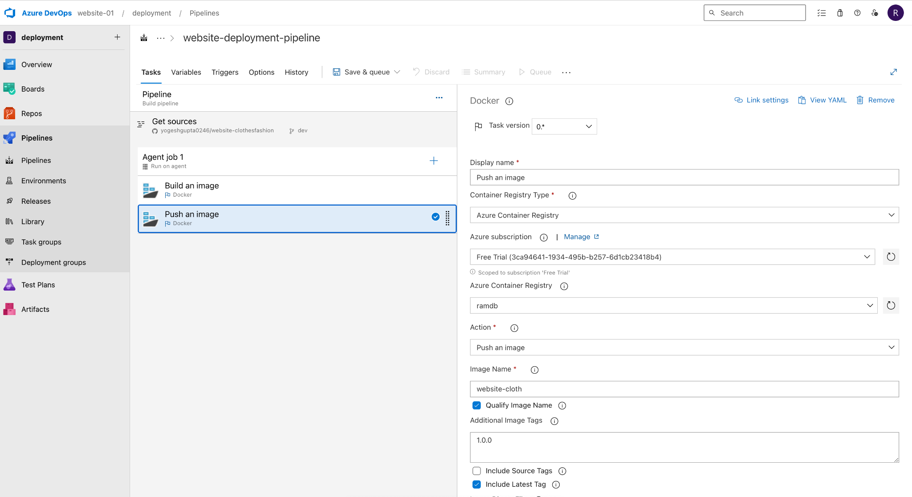

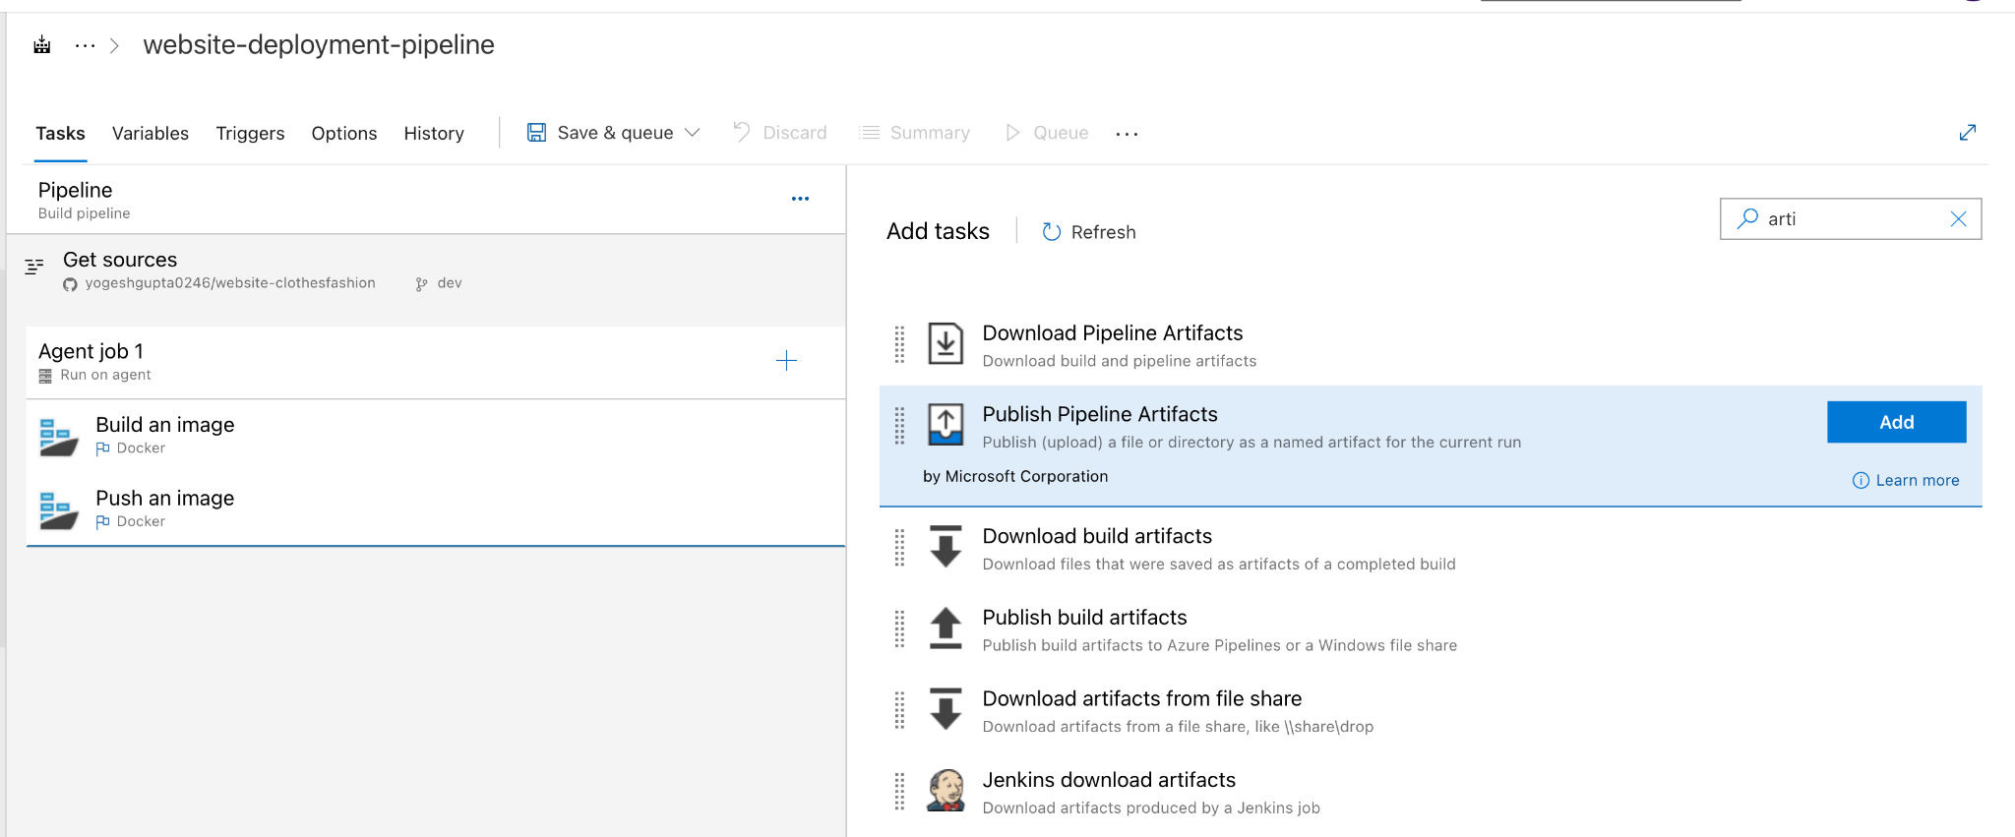

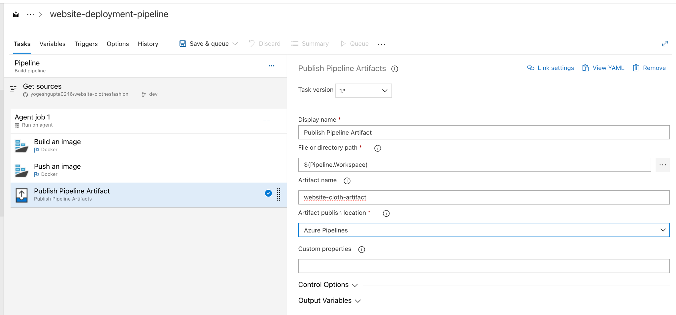

Click on Save

Now run the Pipeline

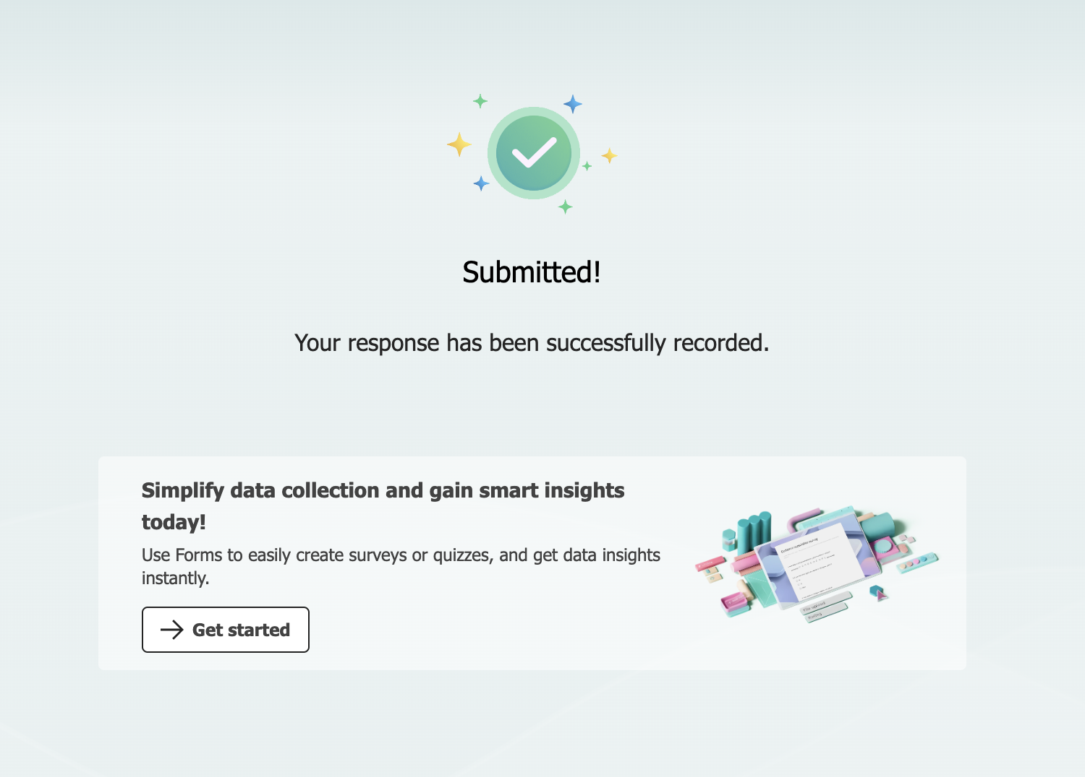

How to trigger Azure pipeline: → Go to pipeline →trigges → check mark on Enable continuous integration

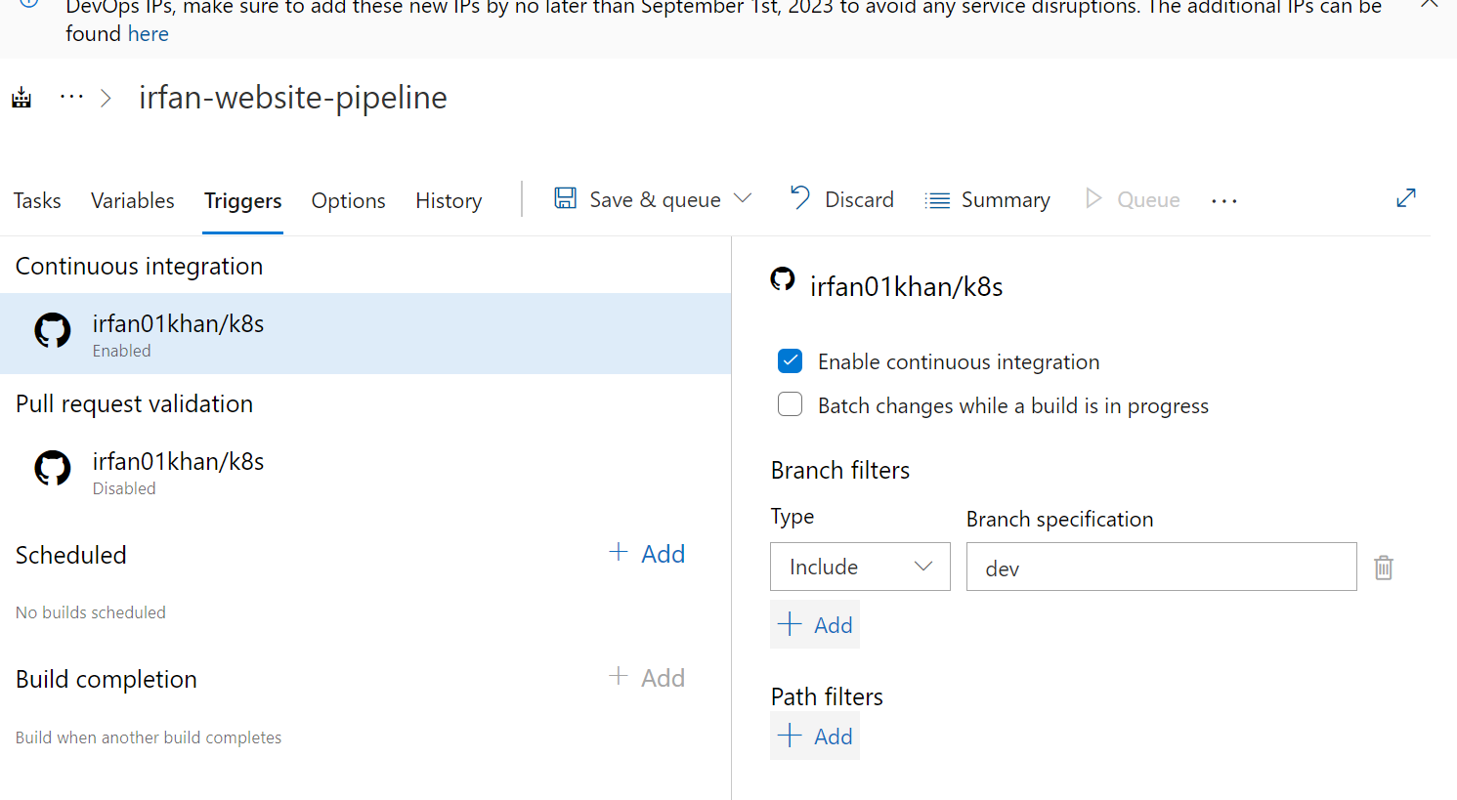

How to email configuration in azure pipeline for notifications:
Click on project →project setting → notification →Delivery setting →Delivery Email Address
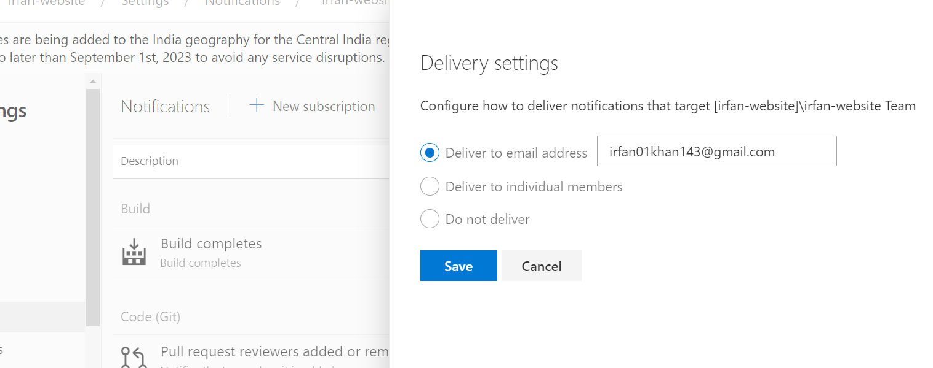

Release Create:-
- Go to pipeline →new pipeline →search →deploy to k8s cluster
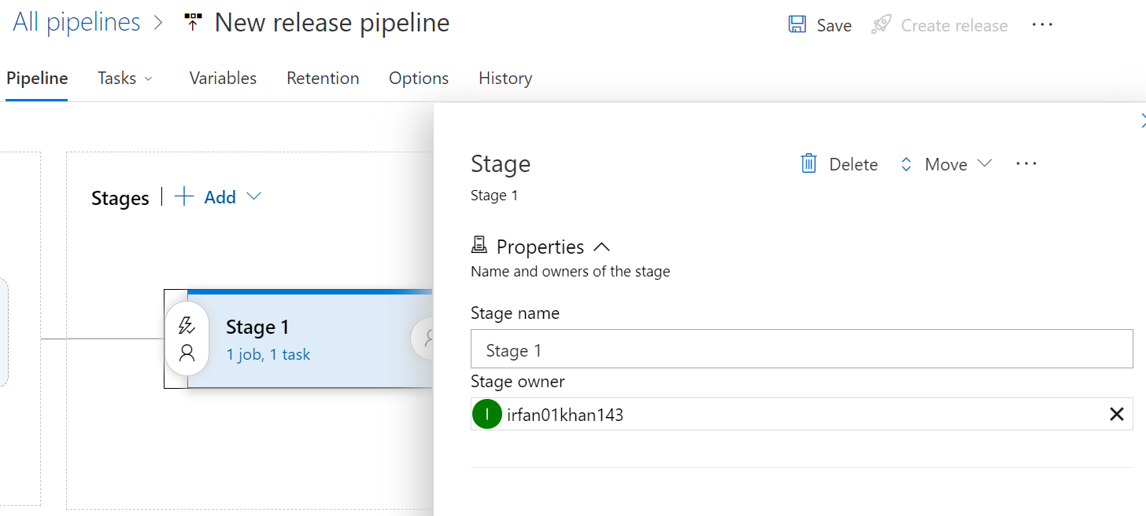

Then save:-
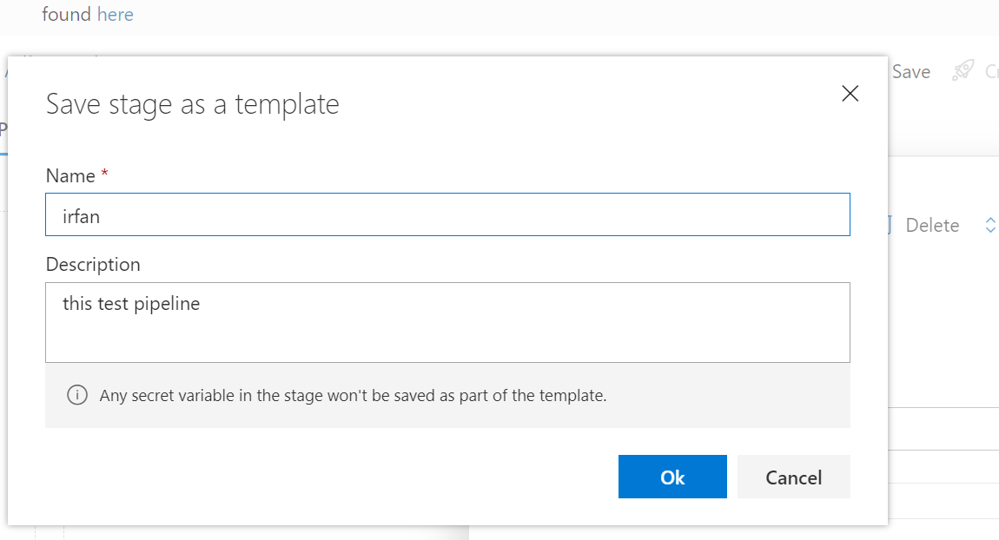

Then add artifact:-
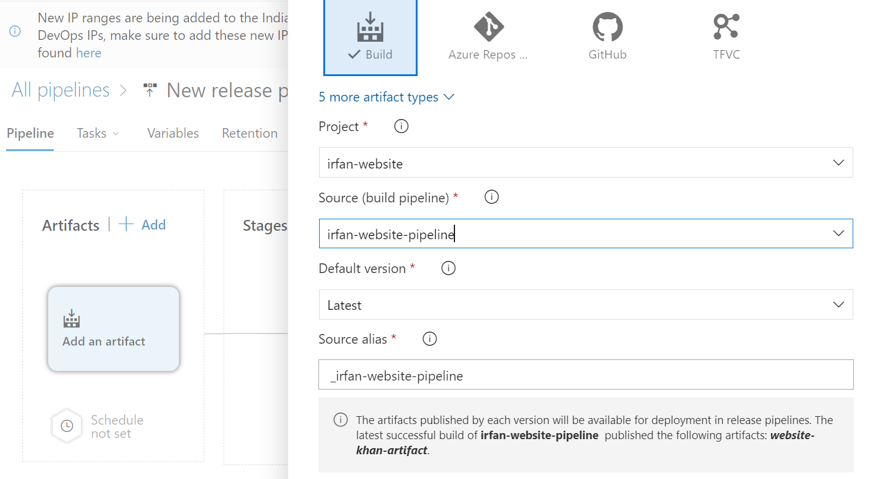

-Now go to Release →-new Release and give new name
-Now click on stage 1(1 job 1 tasks) →

-go to Agent job

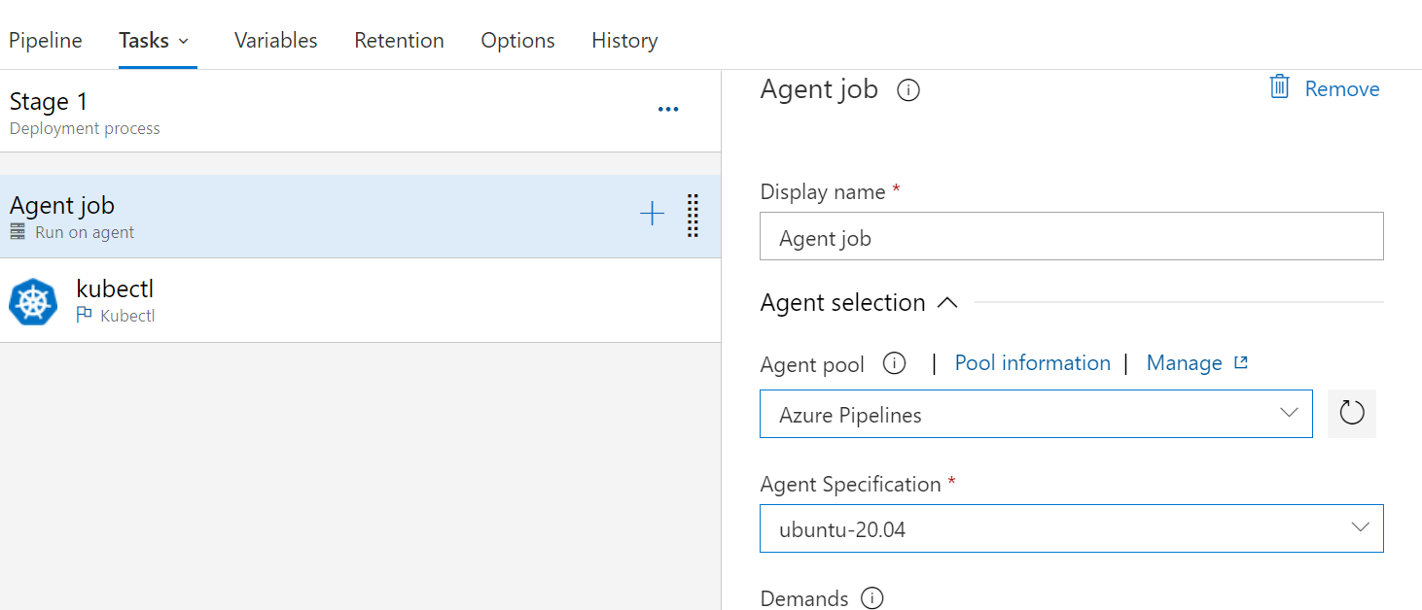

-Go to kubecti— give display name (kubecti apply)-----make Kubernetes service connection—--
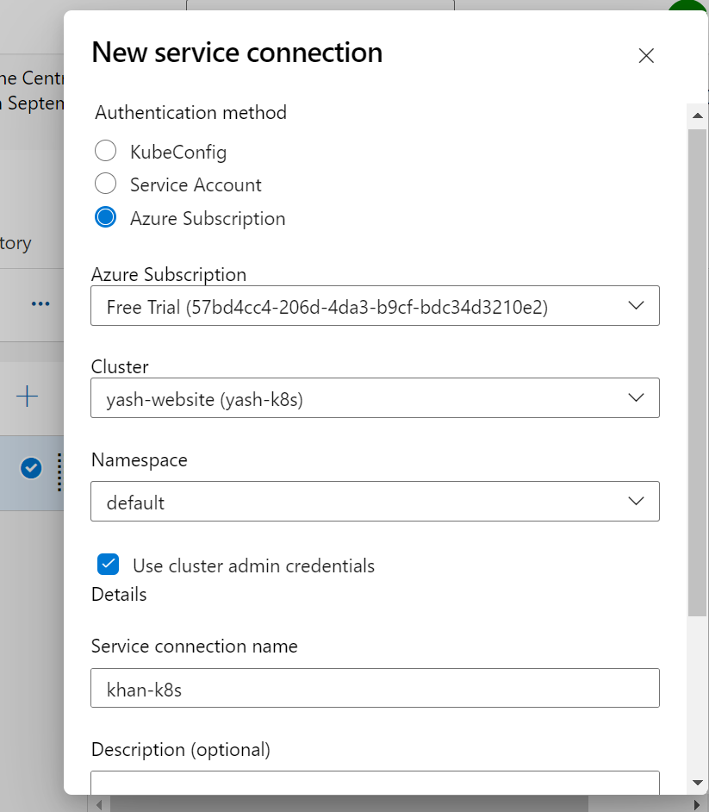

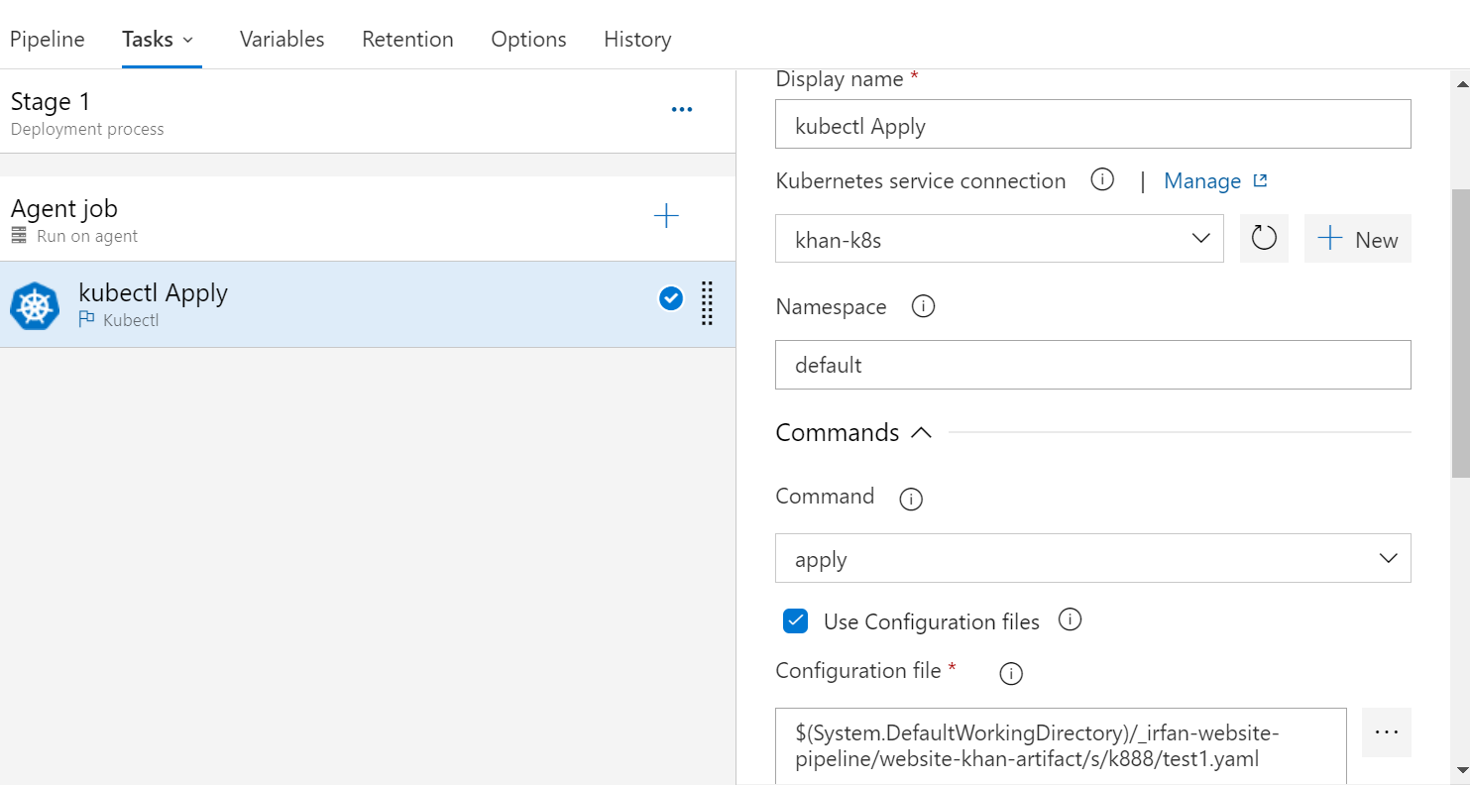

Save & release:

Now go to Azure k8s:
-service & ingresses—-------create—------apply a yaml
After paste you can see your public ip …..

